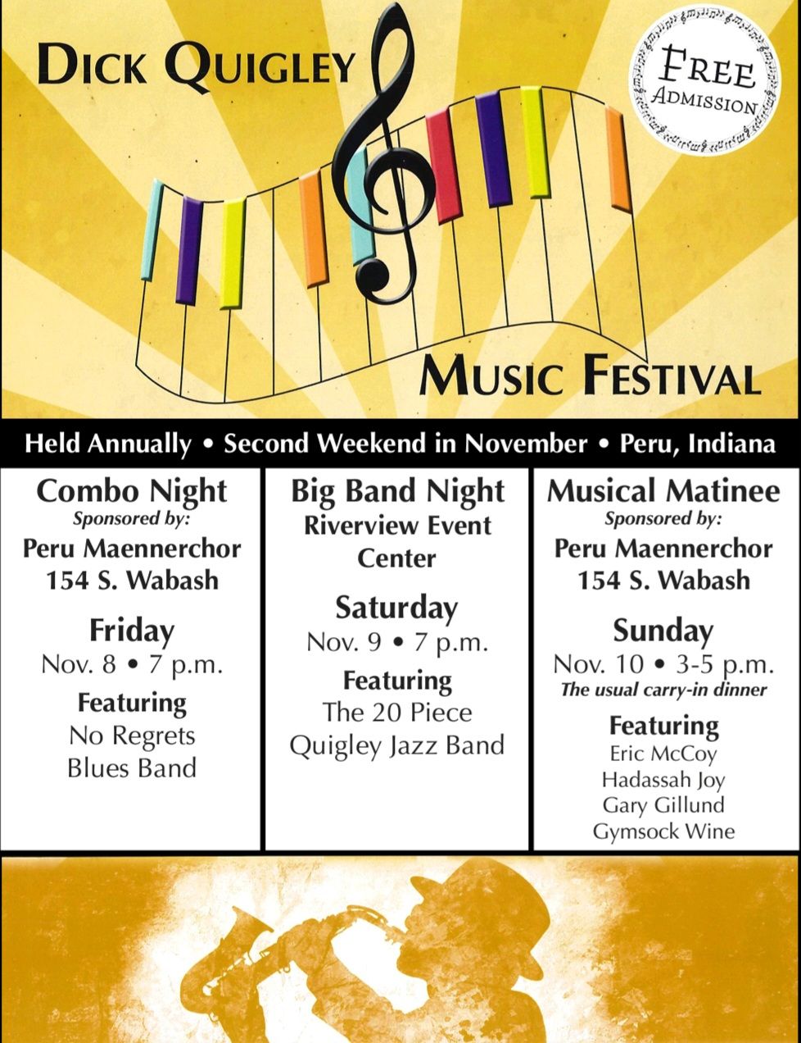

Thank you for your support of the
Dick Quigley Music Festival!

Name___________________________________________________________________________________

Address _________________________________________________________________________________

City_________________________________________St_____________Zip___________________________

Please make check payable to:
Peru Circus Festival Band, Inc.
31 W Seventh St.
Peru, In 46970

The Circus Band, since we are a 501(c)3 has been designated as the legal financial representative for the Quigley Music Festival.

Gift amount: □ $50 □ $100 □ $250 □ Other $_________________________

